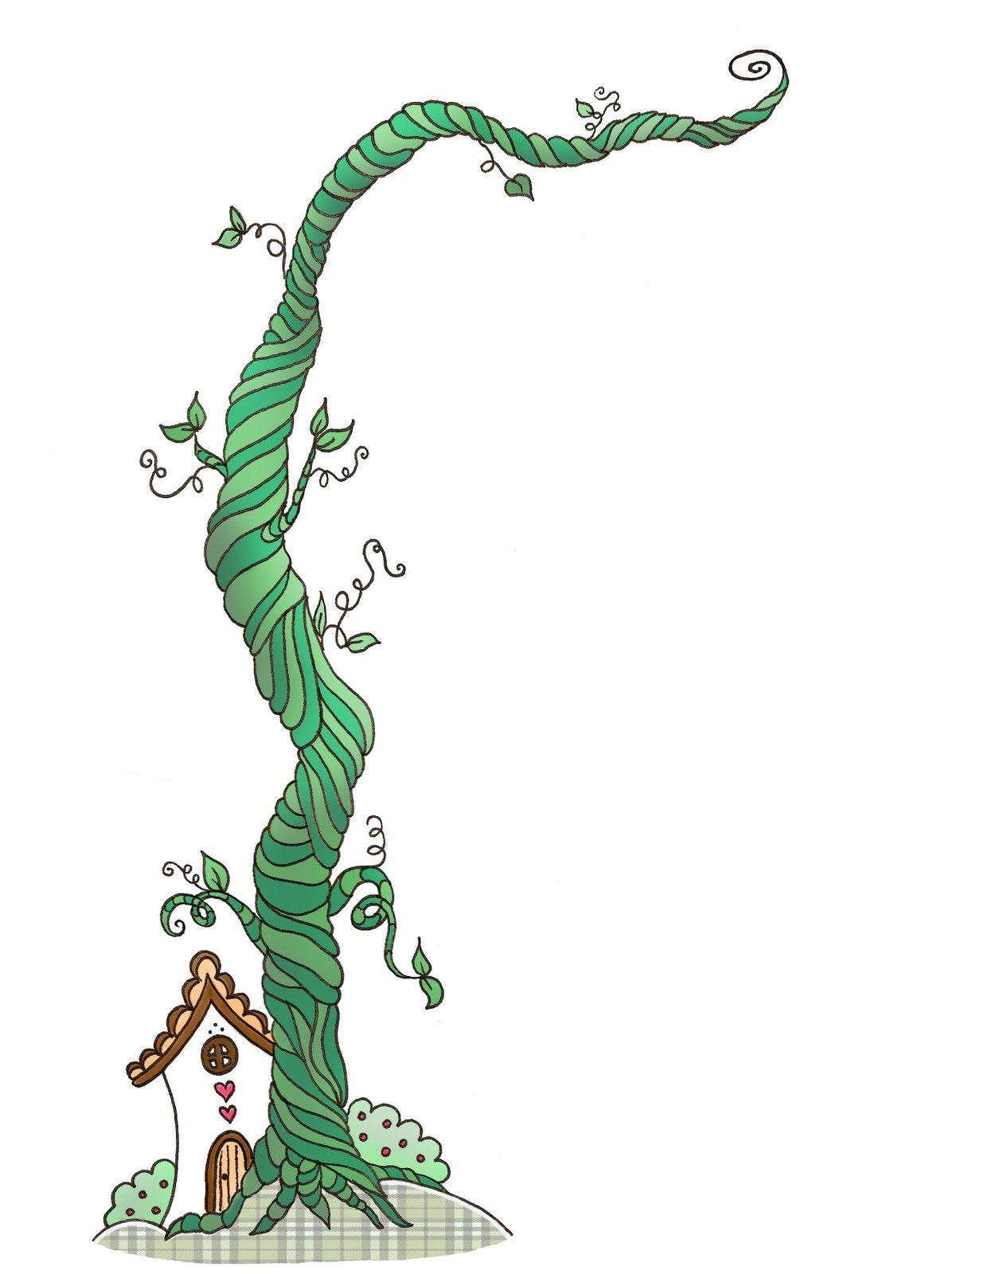
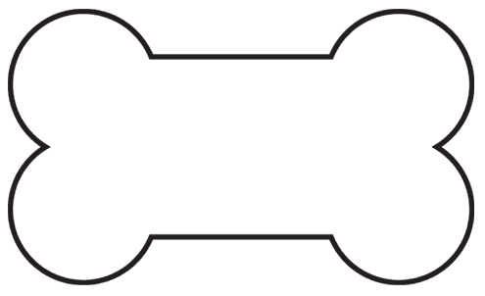
Living Seed Necklace
Kidz Klub
Lesson Learned: What does a seed need in order to grow into a sprout? Soil, water, warmth, air.
Experience: A hands-on experience of observing a seed change from seed to plant. The child is given a sense of responsibility in caring for their seed.
Materials:
1 mini zip lock plastic bag with hole punched (represents air)
1 cotton ball sprayed with water, moist but not soaking (represents soil and water)
1 bean seed, presoaked overnight just prior
yarn, scissors, spray bottle
Directions:
Place moistened cotton ball and 1 bean inside plastic bag and seal top of bag. Put yarn through hole in plastic bag and tie 2 ends of yarn together. Slip over child’s head and wear as a necklace. Place necklace under child’s shirt or in a pocket. The child’s body will produce heat to represent the warmth of the sun. At bedtime, the necklace can be put under child’s pillow for warmth. Optional method: Tape seed bag to a sunny window and watch the seed grow.
After the beans have sprouted, they may be planted in cups or soil or in the garden.
Nashville Demonstration Organic Garden Kidz KluB at Howard County Farmers' Market

